We are an employer required by law to carry out Gender Pay Reporting under the Equality Act 2010 (Gender Pay Gap Information) Regulations 2017. This involves carrying out six calculations that show the difference between the average earnings of men and women in our organisation; it will not involve publishing individual employee’s data.
We are required to publish the results on our own website and a government website. We will do this within one calendar year of April 5th. The data below is taken from a snapshot on 31st March 2023.
We can use these results to assess:
- the levels of gender equality in our workplace
- the balance of male and female employees at different levels
- how effectively talent is being maximised and rewarded

The challenge in our organisation and across Great Britain is to eliminate any gender pay gap.

The results of these statutory calculations are:
- Mean Pay Gap
The difference between the mean hourly rate of pay that male and female full pay relevant employees receive is 18.27%
- Median Pay Gap
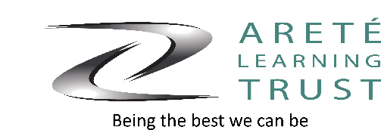
The difference between the median hourly rate of pay that male and female full pay relevant employees receive is 35.24%

- Mean Bonus Pay Gap
No bonuses were paid to staff in the reporting period.
- Medium Bonus Pay Gap
No bonuses were paid to staff in the reporting period.
- The Proportion of males and females receiving a Bonus Payment No bonuses were paid to staff in the reporting period.
- The Proportion of males and females in each quartile pay band

Lower Quartile | Lower Middle Quartile | Upper Middle Quartile | Upper Quartile
21% Male  79% Female | 31% Male  69% Female | 28% Male  72% Female | 32% Male  68% Female

Supporting Statement
The Areté Learning Trust is committed to the promotion of quality and opportunity and choice for employees and supports the fair treatment of all staff irrespective of gender through our transparent recruitment processes, pay policy and professional development.

